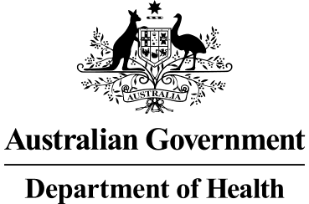

# Deputy Secretary

Mr Jason Lange Executive Director

Office of Best Practice Regulation Department of the Prime Minister and Cabinet 1 National Circuit

BARTON ACT 2600

Dear Mr Lange

# Regulation Impact Statement - Applying greater rigour to certification for hospital admission - Second Pass Final Assessment

I am writing in relation to the attached Regulation Impact Statement (RIS) prepared for

*Applying greater rigour to certification for hospital admission*.

I am satisfied that the RIS addresses the concerns raised in your letter of 15 April 2021. Specifically the document:

* uses the RIS questions as headings, except net benefits provided under each option;
* described the policy problem to address misunderstandings from the first pass;
* addressed a series of minor issues; and
* quantified the regulatory burden.

The regulatory savings are $0.4 million per year.

Accordingly, I am satisfied that the RIS is now consistent with the six principles for Australian Government policy makers as specified in the Australian Government Guide to Regulatory Impact Analysis.

I submit the RIS to the Office of Best Practice Regulation for formal final assessment. Yours sincerely

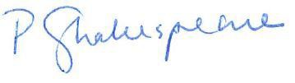

Penny Shakespeare Health Resourcing Group

8 May 2021