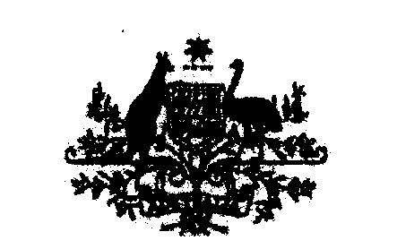
SENATOR THE HON PENNY WONG
Minister for Finance and Deregulation

REF: C10/2571
The Hon Mark Dreyfus QC MP
Cabinet Secretary
Parliament House
CANBERRA ACT 2600

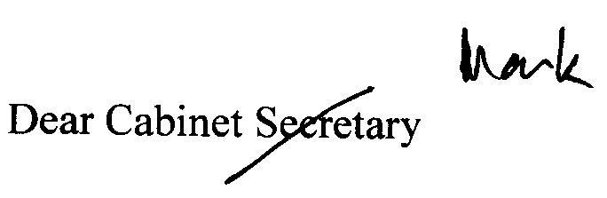
Thank you for your letter of 1 October 2010, concerning arrangements for the application
of the Government’s Best Practice Regulation Guidelines to undertakings made by the
Government in relation to the Australian Greens and to the Independent members of the
House of Representatives.

I note your advice that, for the purposes of the best practice regulation requirements, the undertakings
set out in The Australian Greens & The Australian Labour Party (‘the Parties’) —Agreement;
The Australian Labour Party & the Independent Member (Mr Tony Windsor and Mr Rob Oakeshott)
(‘the Parties 9 — Agreement; and the Hon Julia Gillard & Mr Andrew Wilkie (‘the Parties') — Agreement
should be treated consistent with the arrangements which apply to election commitments.

The Office of Best Practice Regulation will give effect to this advice and, in the interests of transparency,
will publish your letter on its website.

Thank you for your advice on this matter.

Yours sincerely

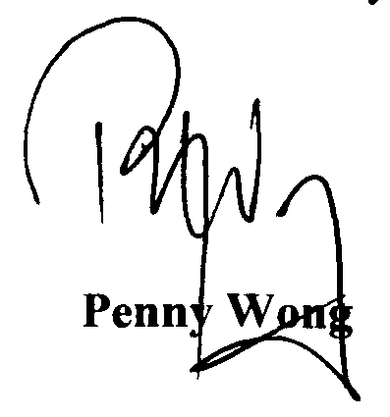

Parliament House, Canberra ACT 2600 - Telephone: (02) 6277 7400 - Facsimile (02) 6273 4110

