Early Assessment of an Impact Analysis
July 2023

Summary
The Australian Government Guide to Policy Impact Analysis (The Guide) sets out three stages of formal assessment undertaken by the Office of Impact Analysis (OIA) for an Impact Analysis:
Assessment stage | Requirement | Timing
Early Assessment | Optional  (best practice) | Prior to consultation or non-final decision point
First Pass Final Assessment | Mandatory | To inform a final decision
Second Pass Final Assessment | Mandatory | To inform a final decision
At each assessment stage, OIA provides a formal written assessment on the quality of analysis in the Impact Analysis, as well as the quality of process. Unlike a Second Pass Final Assessment which includes a formal rating of either: Insufficient, Adequate, Good Practice or Exemplary Practice, OIA notes the submission of an Impact Analysis for Early Assessment but does not assess its quality against the four tiers.
Completing an Impact Analysis for Early Assessment is a prerequisite for an Impact Analysis to be considered for the Exemplary Practice rating at Second Pass Final Assessment.

What is an Early Assessment of an Impact Analysis
An Early Assessment of an Impact Analysis answers the first four Impact Analysis questions and outlines a plan for consultation.
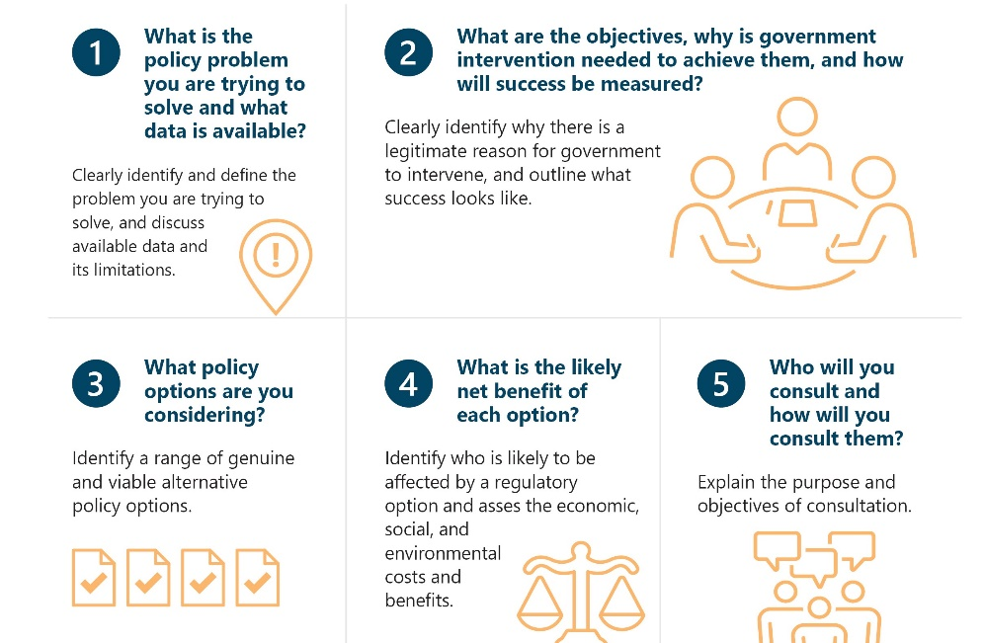

What is the purpose of an Early Assessment of an Impact Analysis?
An Early Assessment of an Impact Analysis is used for consultation or to inform a non-final decision point. It allows you to test your initial policy options and analysis with stakeholders or provide preliminary analysis to decision makers. It presents a clearly defined problem, potential options to solve this problem, and an early consideration of likely impacts, well in advance of the final decision. The document is designed to be reacted to and corrected by stakeholders, not as a final decision making tool. It also provides decision makers with an appropriate level of information at the early stage of the policy development process.
The assistance and support you can expect to receive from the OIA will be much more in depth when you undertake an Early Assessment. This is because undertaking an Early Assessment allows you to test the quality of your analysis with OIA.
OIA will provide feedback and suggestions on content, structure, methodology and consultation design to improve the analysis in your Impact Analysis.

Do you need to prepare an Early Assessment of your Impact Analysis?
Submitting an Impact Analysis for Early Assessment demonstrates that you are undertaking a rigorous process in conducting Impact Analysis.
However, it is not compulsory under the Australian Government’s Impact Analysis framework.
To be eligible for an Exemplary Practice rating at Final Assessment, your Impact Analysis must be submitted for a formal Early Assessment. However, submitting an Impact Analysis for Early Assessment does not guarantee a rating of Exemplary at Final Assessment.
Please note, assessment of the process can only maintain or move the analysis assessment lower. For example, an exemplary level of analysis could be dragged down if the policy making and Impact Analysis process were poor. Whereas an exemplary process would not improve the overall assessment of an Impact Analysis that contained an analysis rated as merely adequate. An Exemplary rating at Final Assessment requires an exemplary policy development process, as well as exemplary quality content in the Impact Analysis.

Process for an Early Assessment Impact Analysis
Following OIA’s advice that an Impact Analysis is required, you should start drafting the Impact Analysis for Early Assessment as soon as possible. It is designed to run concurrently with your policy development process as an integrated component, not undertaken in isolation.
First, address the first four Impact Analysis questions. These are the same first four questions that you will respond to in your First Pass Final Assessment and Second Pass Final Assessment of your Impact Analysis. Information on how to address these questions and the relevant analysis to include is outlined in The Guide and suggested templates are on the OIA website.
Next, outline the proposed consultation plan. This should include:
- Explanation of the purpose and objectives of consultation
- A plan for conducting consultation
- Explanation of who should be consulted—and who does not need to be consulted
- A strategy for the most efficient and meaningful consultation
- A summary of the major topics to be covered and what issues might be raised
When you are confident with the quality of your Impact Analysis, submit this document to OIA for formal assessment. The final version is provided to OIA, along with a Certification Letter signed at the Deputy Secretary level to OIA.
Prior to formal submission, policy makers are encouraged to submit drafts to OIA for informal feedback. Whilst you can only submit an Impact Analysis for Early Assessment once, there is no limit on the number of drafts that can be sent to OIA.

How OIA assesses an Early Assessment
Following formal submission, OIA will provide a formal written assessment with detailed comments to improve the quality of analysis before it is released for consultation. This letter is not published.
For Early Assessment, OIA assesses the quality of your Impact Analysis with two key criteria in mind:
- Is the information provided proportionate to the stage of the process, the problem being addressed and the options presented?
- Does the Impact Analysis contain an appropriate plan for consultation, including an explanation of the purpose and objectives of consultation?
In addition to detailed comments and feedback, OIA’s response will generally consist of one of the following:
OIA response | Agency Action
The Impact Analysis is of adequate quality to be released for consultation or to inform a non-final decision. | No further action, ready to release for consultation or provide to decision maker.
The Impact Analysis requires minor updates before being released for consultation or being used to inform a non-final decision. | Action minor feedback, no requirement to re-consult with OIA. Ready to release for consultation or provide to decision maker.
The Impact Analysis requires considerable work and is currently of an insufficient quality to be released for consultation or be used to inform a non-final decision. | Action feedback as outlined by OIA and consider resubmitting to OIA for updated advice on the content prior to being released for consultation or being used to inform a decision.  If the Early Assessment finds your analysis insufficient or your consultation plan unsatisfactory, and this is not addressed, it may attract a detrimental assessment of your Impact Analysis at the Final Assessment stage.

OIA assistance
You are encouraged to advise OIA of your intentions to submit an Early Assessment so guidance and feedback on drafts can be provided prior to formal submission.
OIA encourages agencies to organise meetings and discussions during the drafting process to support the Impact Analysis writing process. These meetings can be tailored to developing specific parts of the Impact Analysis, such as the problem section, or can be a broader overview of the Impact Analysis timeline.
For further information on any of the topics covered in this guidance note, contact OIA on (02) 6271 6270 or at helpdesk-OIA@pmc.gov.au.

Helpful Links
Best practice consultation
Australian Government Guide to Policy Impact Analysis

