Competition and Regulation
July 2023
The purpose of this guidance note is to assist policy makers to understand the additional ‘competition tests’ required in Impact Analysis in which the preferred option restricts competition.

Competition tests
The way businesses compete against each other greatly affects the welfare of consumers. In the absence of competition, consumers are likely to be worse off. Competition can also be a driver of efficiency and innovation, both of which lead to enhanced productivity. For that reason, the Australian Government Guide to Policy Impact Analysis and the Regulatory Impact Analysis Guide for Ministers’ Meetings and National Standard Setting Bodies, require that the competition impacts of new regulatory proposals be examined in Impact Analysis.
Furthermore, both the Guide to Policy Impact Analysis and the Regulatory Impact Analysis Guide for Ministers’ Meetings and National Standard Setting Bodies require additional tests for Impact Analysis that recommends a regulatory proposal that the Office of Impact Analysis (OIA) has assessed as restricting competition. This is required to meet the Commonwealth’s commitments under the intergovernmental Competition Principles Agreement, which was designed to promote competition and established by COAG in 1995.
The competition tests that must be met for a proposal that restricts competition are:
- there are no alternative means of achieving the Government’s objectives without restricting competition
- this regulatory proposal generates a net benefit to the community.
The tests are designed to prevent proposals that restrict competition, unless they are in the public interest. Figure 1 sets out the steps involved in completing the tests in Impact Analysis.
This guidance note explains some of the concepts in the competition tests, such as:
- how regulation can restrict businesses from competing
- considering less restrictive alternatives
- assessing the impacts from a restriction on competition
- how OIA assesses that a policy change restricts competition.
- Steps to complete the competition tests in Impact Analysis
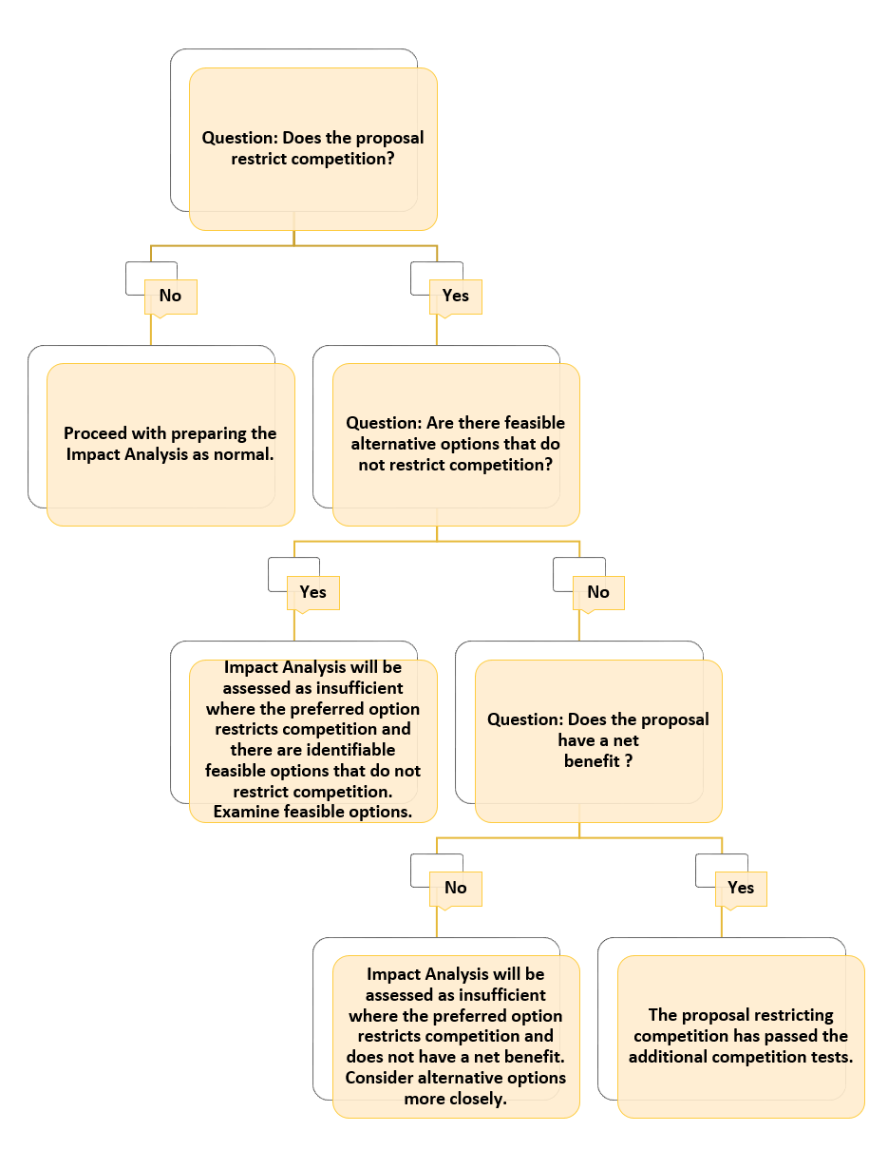

How policies can restrict businesses from competing
The types of policies that restrict competition are those that:
- limit the number or types of businesses
- limit the ability of businesses to compete
- reduce the incentive for businesses to compete
- limit the choices and information available to consumers.
Understanding the ways that regulation can restrict competition is essential for analysing the impacts on business and consumers in Impact Analysis.
The following lists, which are based on the Organisation for Economic Co-operation and Development (OECD) Competition Assessment Toolkit, describe the four ways that regulation can restrict competition. It is possible for a regulatory proposal to restrict businesses from competing in several different ways.

Limit the number or types of businesses
A regulation that limits the number or types of businesses in a market will mean that some businesses will be unable to enter that market and compete. Such regulations include those that:
- award exclusive rights for a business in a market (for example, restricting the ability of businesses to supply goods or services in specific geographic locations)
- require businesses to be licensed or authorised
- limit the ability of some types of businesses to provide a good or service
- significantly raise the costs of entry or exit
- restrict the geographical flow of goods, services, capital or labour.

Limit the ability of businesses to compete
A regulation specifying a product’s price, quality, the location where it can be sold or how it is promoted will limit the ability for businesses to compete against each other. Such regulations include those that:
- limit the ability of businesses to independently set their prices for goods or services (price regulation)
- limit the freedom of businesses to advertise or market their goods or services
- set standards for product quality that provide an advantage to some businesses over others
- significantly raise costs of production for some businesses relative to others (for example, by creating a standard that is inconsistent with imported goods, or treating existing businesses in the market different from new entrants).

Reduce the incentives of businesses to compete
Regulations can affect the behaviour of businesses not only by changing their ability to compete, but also by altering their incentives to act as rivals.
For example, a regulation that restricts a business from expanding its market share or growing its profit may reduce the vigour with which that business competes against another business. Some regulations also have the effect of reducing the willingness, ability or incentive of customers to switch between different suppliers, which may also reduce the incentive for businesses to compete.
Regulations that may reduce the incentives for vigorous competition between businesses include those that:
- create a self-regulatory or co-regulatory regime that includes rules that reduce incentives for businesses to compete
- exempt the activity of a particular industry or group of suppliers from the operation of competition law.

Limit the choices and information available to consumers
Regulation that limits the choices and information available to consumers may dissuade businesses from entering a market or reduce competition in the market. Such regulations include those that:
- limit consumers’ ability to choose who to buy from
- reduce the customers’ ability to move between suppliers by imposing high ‘switching costs’
- limit information available to consumers and thereby reduce their ability to choose effectively between competing businesses.

Considering less restrictive alternatives
If your proposed regulation would restrict competition, you must demonstrate that the only way of achieving the Government’s policy objective is to do so. This means that you must first rule out alternative solutions that do not restrict competition, including ‘no regulation’.
Regulation that is less restrictive on competition:
- allows consumer choice
- allows imported goods
- imposes compliance costs that are proportional to the size of the businesses involved
- allows new competitors to enter the market.
Alternative or complementary options to address a problem or achieve the Government’s objectives that are potentially less restrictive on competition include:
- using government funding (for example, funding to clean up pollution, more funding for existing enforcement activities or funding to help older people to pay for health care)
- imposing taxes and penalties (for example, placing a tax on polluters, increasing existing penalties or having progressive taxation arrangements)
- strengthening existing arrangements (for example, by increasing resources for enforcement)
- using insights from behavioural economics to develop non-regulatory or light-handed regulatory options (for example, making it easier for consumers to make better decisions or creating incentives for desired behaviours).

Assessing the impacts from a restriction on competition
If your proposed regulation restricts competition, you must demonstrate in Impact Analysis that it will generate a net benefit to the community as a whole. This means that the benefits of the regulation (in fixing an identified problem or achieving a desired social outcome) should outweigh the costs. Your Impact Analysis needs to assess both the benefits and the costs of the change, including those resulting from restrictions on competition.

Understanding benefits
The benefits from a regulation are derived from addressing a problem or achieving a social objective. This section identifies some common market problems and social policy objectives in which competition is important.
Note that it is easier to quantify benefits when you know the size of the problem. Issues which a new regulation might address include:

Problems associated with the structure of a market
Excessive market power due to an imbalance in the structure of a market can lead to monopoly-type power, which can create incentives for a supplier to increase prices and reduce the quantity and quality of goods or services in order to increase profits. The costs to the consumer from this practice will generally be greater than the benefits that the monopolist receives.
If a seller has excessive market power, that may exacerbate the split incentives that exist between a buyer and seller. For example, in a tight rental market, landlords seeking to maximise their profits will underinvest in energy-saving measures for their investment properties. While this practice will save the landlord some expenses, their savings may be less than the higher energy costs incurred by the tenant. Additionally, where there are few buyers and many competing sellers, buyers may be able to exercise monopsony-type power. This may enable the buyer to ask for lower prices and demand higher quality goods.
The intensity at which businesses compete is not a function solely of the number of suppliers operating in the market. A market with two sellers, or even only one seller, can be competitive as long as there is a strong threat that a new competitor could enter the market. In such a case, a regulation that makes market entry harder will reduce competition.

Problems associated with externalities
A negative externality occurs when producing or consuming a good has a negative effect on a third party (pollution from factories is an example). The opposite is a positive externality, which occurs when a party not involved in a transaction benefits from it (for example, from the construction of a public road).
A public good can involve a form of positive externality when others cannot be excluded from receiving benefits from it (non-excludable) and the use of it by one entity does not reduce the benefits of it for others (non-rival). An example would be an unpatented invention that could be copied by everyone once it is announced. This can lead to a free-rider problem, which can diminish the incentives to invest, including in a public good.

Problems associated with the transaction of a good or service
Information asymmetry occurs when one party in a transaction has more information than the other party. A lack of information has the potential to lead to consumers making less than optimal purchasing decisions. Information asymmetry can then lead to higher transaction costs in the form of the time taken by consumers in researching the background of sellers and the time taken in finding the best deal.
Where there is great uncertainty about the quality of a good, this can also lead to a market for ‘lemons’, in which bad products drive good products out of the market. Those offering higher quality goods cannot sell them because buyers who are unsure of the goods’ quality are unwilling to pay higher prices.
Information asymmetry can also lead to a principal–agent problem in which the principal is uncertain whether their agent is acting in the principal’s best interests or their own. For example, when a medical specialist prescribes expensive treatment, a patient might be uncertain whether it is truly necessary for their health, or because it will generate income for the specialist.
Similarly, information asymmetry can lead to moral hazard when the unobserved actions of one party may mean that they take greater risks at the expense of another party. This problem is typical in the insurance industry, in which insured parties may take on more risk because the consequences of the risk to them have been reduced.
In recent years, the use of behavioural economics (which draws on psychology and the behavioural sciences in assessing consumer behaviour) in public policy and regulatory considerations has increased. Behavioural-type problems are often defined as those arising from decisions that individuals make, or are perceived to make, against their own best interests. Behavioural market failures can be caused by loss aversion, reliance on reference points, time inconsistency of preferences, or social factors.

Achieving social objectives
Governments may have a number of social policy objectives related to: utility services, health care, education, public safety, transport, the equitable distribution of wealth, or positive action to address discrimination.
Regulations that try to achieve particular social objectives may also restrict businesses from competing against each other.

Understanding the costs of restrictions on competition
The primary cost of a restriction on competition is that it reduces the incentives for businesses to act in ways that benefit consumers. Regulations that impose compliance costs on businesses can prevent businesses from taking up opportunities, reducing competition in the market.
It is very hard to quantify this cost because of the dynamic and unpredictable nature of competition between businesses. Consequently, many of the costs of restrictions on competition need to be described in qualitative terms, such as the potential for higher prices, lower quality goods, longer waiting times and reduced services.

How restrictions on competition reduce incentives for businesses to act in ways that benefit consumers.
Vigorous competition will ordinarily benefit consumers by reducing prices, increasing the quality or quantity of the offer. It may also lead to increased production and rewards for innovation.
Restrictions on competition may reduce incentives for businesses to lower their prices. With less competition, businesses may raise their prices to increase profits, without the fear that competitors will undercut them and take their customers. This may mean that some consumers will buy less of a product or none at all. Even if they buy the same amount, they will have less money to buy other products. In this way, restrictions competition may cause a misallocation of resources so that consumers are getting less even though they are paying more.
Reduced competition may reduce incentives for businesses to be more productive. Strong competition usually forces them to cut costs and find new and improved methods of production over time, which increases productivity. Without those improvements, less of a product may be available for consumption or the price of the product may rise.
Restrictions on competition may reduce incentives for businesses to adapt to change, leading to lower capital expenditure or spending on research and development to attract new customers. In the longer term, this may make those businesses more vulnerable and less adaptable to changes in economic conditions, technology, consumer tastes and government policy.
The Australian Competition and Consumer Commission’s Authorisation guidelines 2013 use these concepts (referred to as allocative, productive and dynamic inefficiency) when describing the detriment from a reduction in competition.

How restrictions on competition may make consumers worse off
Market researchers have found that consumers value goods and services according to ‘the four P’s’: product, price, place and promotion.
Product. Consumers value a good or service that satisfies their own unique desires. They might value a product highly for its size, quality, colour or content, or a service because it is reliable and professional. Consider whether your proposed regulation would reduce the range of goods and services in the market by reducing competition.
Price. Consumers prefer to pay less for a good or service. Consider whether your proposed regulation will lead to higher prices by restricting competition (for example, by making it harder to import and sell goods produced outside Australia).
Place. Consumers value convenience. They want quick access to goods and services close to where they live or work. Will your proposed regulation, by reducing competition, force them to wait longer or travel further?
Promotion. Consumers want to know what is available in the market, what it costs, and what the seller will do about it if the product is faulty or the service is substandard. This is why businesses advertise and run customer service departments. Will your proposed regulation reduce their ability to advertise and service their customers, which will also reduce their competitiveness?
It is likely that any regulation restricting competition will make consumers worse off in at least one of the four P’s.

Other factors to consider when assessing the costs from a restriction on competition
Other questions you should ask are:
- Are similar goods or services still available? If so, that may reduce potential impacts on consumers.
- Are imported goods still available? If so, that may lower the price for consumers.
- Are barriers for new businesses entering the market low or high? Low barriers can increase competition and reduce prices.
- Is the market new or highly innovative? If it is it may be more sensitive to regulation given greater risks associated with investing in new or innovative markets.

How OIA assesses that a policy change restricts competition
To determine whether your proposed policy change would restrict competition, consult OIA as early as possible during policy development. OIA’s assessment will be based on the OECD competition toolkit.
Some policy changes may impose minor restrictions on competition but still be acceptable. For example, a change that increases compliance costs will restrict competition by increasing the barriers to market entry, but the impact might not be significant. For practical reasons, OIA will find that a proposed change would restrict competition only where the restriction on competition has costs that are relatively significant to consumers, before the benefits are considered. Importantly, the significance of the costs is assessed not by reference to the whole economy, but by reference to a specific market or markets. This can include niche markets with just a few small businesses operating; while such markets and costs are not a major part of the economy, they are still important to some consumers.

Assistance
If you have any questions about this guidance note, email OIA at helpdesk-OIA@pmc.gov.au or call
(02) 6271 6270.
Further information on the Impact Analysis process is in the Australian Government Guide to Policy Impact Analysis.

